**Assessment Cover Page**

|  |  |
| --- | --- |
| *Student Full Name* | Derek O’Hara |
| *Student Number* | sbs24018 |
| *Module Title* | Machine Learning |
| *Assessment Title* | CA1 Project |
| *Assessment Due Date* | 28th April 2024 |
| *Date of Submission* |  |

**Declaration**

By submitting this assessment, I confirm that I have read the CCT policy on academic misconduct and understand the implications of submitting work that is not my own or does not appropriately reference material taken from a third party or other source.

I declare it to be my own work and that all material from third parties has been appropriately referenced.

I further confirm that this work has not previously been submitted for assessment by myself or someone else in CCT College Dublin or any other higher education institution.

Contents

Introduction 1

Data Characterization and Pre-processing 1

References 12

Dataset: 12

Github: 12

Code comments: 12

# Introduction

Analysing and predicting student performance is crucial for educational institutions to improve efficiency. It helps identify students with low academic achievements early on, high dropout rates, and delays in graduation (Daniel, B. 2015). It is very important for educational institutions, to understand the potential of using collected data to improve the learning efficacy and academic achievements of both the individual student and institutions themselves (M. Nachouki and M. Abou Naaj, 2022).

This report aims to explore and demonstrate the application of machine learning algorithms to predict academic success. I will be focusing on predicting a group of students' final grade “G3” in a course based on their prior academic data and demographic features.

The dataset I have chosen is called the “Student Performance Dataset” and can be found at [kaggle.com](https://www.kaggle.com/datasets/devansodariya/student-performance-data). As I become more familiar with the data and using prediction and classification algorithms where appropriate, I hope to be able to identify patterns and insights from the data to achieve my goal. (word count = 160)

# Data Characterization and Pre-processing

This dataset was compiled through a survey of students' math course in secondary school. It is made up of 33 columns/features of both numerical and categorical types and 395 rows. The features comprise of several considerations such as the students past academic performance, demographics, and social factors.

Data preprocessing refers to the technique of preparing (cleaning and organizing) the raw data to make it suitable for a building and training Machine Learning models (K Goyal 2024). My first steps are to load and display the main features of the dataset to get an initial understanding of the data and any obvious relationships or anomalies straight away.

Displaying data types of all the columns in the data frame allows me to assess if the encoding of any categorical variables will be necessary. There are no null values in my dataset, so no need to implement any missing value handling techniques.

I also get the initial description of the metrics of the numerical columns in the dataset. A quick check of the count value also confirms that there are no null values in the numerical features.

A Boxplot of the numerical columns helps to identify any distint outliers (Individual Dots) in the data.

The variable with the widest range of values with a lot of outliers is **absences**, indicating that most students have few absences, but some have a lot more than typical.

The grades categories **G1, G2 & G3** are spread out with several outliers, particularly for the final grade (G3). This suggests varied performance among students, with some scoring much higher or lower than the typical range.

To deal with outliers effectively in your analysis, I may choose to:

* **Keep them**: If they represent valid variations.
* **Remove them**: If they're due to errors or if their extreme values could skew my analysis.
* **Transform them**: Apply a transformation to reduce the impact of outliers, for instance, using a log transformation (S. Anuganti, 2020).

My focus is the grade **G3**, and I want to clearly visualise the distribution of these values. I do this by means of a histogram using matplotlib and seaborn libraries.

Immediately I can see the significant left skewness of the G3 grade distribution. There are 38 cases where G3 is zero. The next lowest mark 4. This indicates that rather than 38 students sitting the exam and getting zero, they did not sit the exam at all.

I similarly plot the distribution of each numerical feature in the data frame.

The correlation matrix heatmap shows that the strongest correlation between **G3** marks is with the marks obtained in **G1** & **G2**. There is a risk of multicollinearity here.

We also see negative correlation between **failures** and **G1**, **G2**, **G3**, which indicates that students with more past failures tend to have lower current grades.

**studytime** is negatively correlated with **failures**, suggesting that more study time is associated with fewer failures.

I try to perform a thorough exploratory data analysis by creating visual relationships between each feature and the target variable, **G3**.

Firstly, I use scatter plots to visualise the numerical features.

I used bar charts to plot the mean of **G3** for each categorical feature and visualise the relationship.

I picked some of the main features and created pair plots to further analyse any patterns. We can still see that the strongest relationships to **G3** are with **G1** & **G2**.

If I take a look at **studytime** in particular, we can see increasing trend in median grades as study time increases but the overall spread is similar. We also see the outliers across all levels were study time did not influence a zero mark.

My next task was to encode the categorical variables into numerical variables using One hot encoding.

If I chart the number of zero grades for **G1**, **G2** & **G3**, zero grades have increased to 38 by G3.

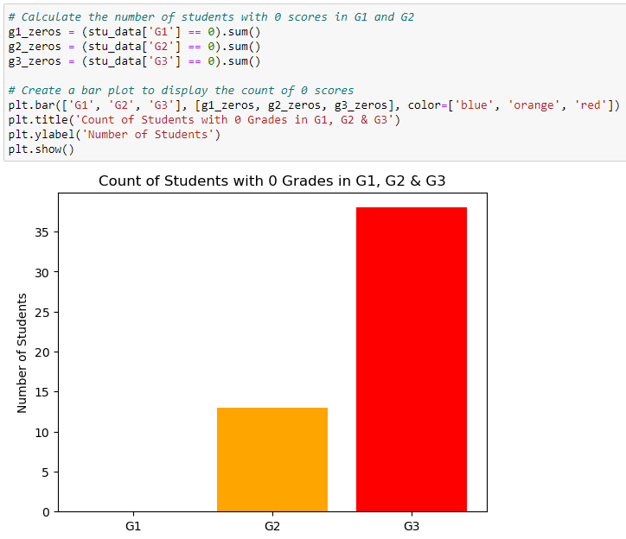

Based on this pattern and the data I have gathered, my analysis from now will continue under the assumption that these 38 students did not sit the exam.

After dropping the 38 zero G3 grades, we can see that the G3 distribution skewness has improved.

te

# References

Daniel, Ben. (2015). Big Data and analytics in higher education: Opportunities and challenges. British Journal of Educational Technology. 46. 10.1111/bjet.12230. Available at: <https://www.researchgate.net/publication/269936924_Big_Data_and_analytics_in_higher_education_Opportunities_and_challenges>

Nachouki, Mirna & abou naaj, Mahmoud. (2022). Predicting Student Performance to Improve Academic Advising Using the Random Forest Algorithm. International Journal of Distance Education Technologies. 20. 17. 10.4018/IJDET.296702. Available at: <https://www.researchgate.net/publication/362839521_Predicting_Student_Performance_to_Improve_Academic_Advising_Using_the_Random_Forest_Algorithm>

Kechit Goyal (2024) 'Data Preprocessing in Machine Learning'. Available at: [https://www.upgrad.com/blog/data-preprocessing-in-machine-learning](https://www.upgrad.com/blog/data-preprocessing-in-machine-learning/)

Suresh Anuganti (2020). How to remove outliers for machine learning. Available at: <https://medium.com/analytics-vidhya/how-to-remove-outliers-for-machine-learning-24620c4657e8>

## Dataset:

Student Performance Dataset (2022) <https://www.kaggle.com/datasets/devansodariya/student-performance-data/data>

## Github:

<https://github.com/derekoharacct/Machine-Learning-CA-1.git>

## Code comments: